Shopping Vocabulary

Useful Vocabulary
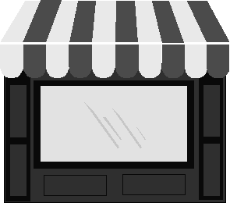 |  | 
Shop(s) | Customer(s) | Cashier(s)
 | 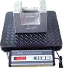 | 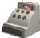
Wallet(s) (m)  Purse(s) (f) | Scales | Till(s)
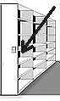 | 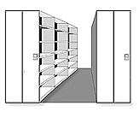 | 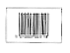
Shelf | Shelves | Barcode(s)
 | 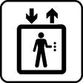 | 
Trolley(s) | Lift(s) | Bag(s)
 | 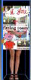 | 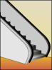
Basket(s) | Changing Room(s) | Escalator(s)
 | Ways to pay
 | 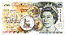 | 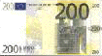
Cheque(s) | Cash | Note(s)
 | 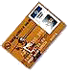
Coin(s) | Credit card(s)  Debit card(s)

Build Up

Where to buy what
 | Chemist's
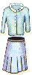 | Ladies Clothing Shop or Boutique
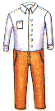 | Mens Clothing Shop or Tailor's
 | Shoe Shop or Cobbler's
 | Jeweller's
 | Electrical Store
 | Toy Shop or Toy Store
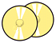 | Record Shop
 | Book Shop
 | Newsagent's
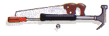 | Ironmonger's
 | Optician's
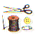 | Haberdasher's
All or most of the above | Department Store
 | Butcher's
 | Fishmonger's
 | Greengrocer's
 | Baker's
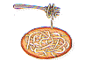 | Delicatessen
 | Grocer's
 | Off Licence
 | Florist's
 | Post Office
All or most of the above | Supermarket

Naturally Speaking

Useful Shopping Phrases
Finding a Shop | Opening Hours
Questions  - Can you recommend a good toy/clothes shop?  - Is there a chemists/supermarket in the area?  - Where can I get toothpaste/pet food?  - Where's the nearest shopping centre?  Answers/Comments  - There's a really good bookshop just around the corner.  - You can buy that here in the hotel.  - The best toy shop is in the shopping centre.  - The nearest one is a few miles away. | Questions  - What time do you open, please?  - What time do you close, please?  - What are your opening hours?  - Are you open all day?  - Are you open on Sundays?  Answers/Comments  - We're open 24/7. (24 hours a day / 7 days a week)  - We're closed at lunchtime, between 12 and 2pm.  - We're open from 9am till 6pm, Monday to Friday.
Shopping for Clothes | Paying
Questions  - Could you help me, please?  - Could you tell me where the ................ department is?  - Excuse me, I'm looking for a .......... .  - Is there somewhere I can try this on, please?  - Does it suit me?  - Do you have this in a (larger/smaller size) (different colour), please?  - Do you do alterations?  - Do you have a refund policy?  - Is this in the sale?  Answers/Comments  - It's too long / short.  - It's too tight / loose.  - The ladies / gents changing rooms are over there.  - You can bring it back and exchange it or get a refund within 2 weeks if you keep the receipt. | Questions  - Do you take credit cards?  - Do you give credit?  - Do you have a loyalty card?  - Does it have a warranty?  - Can I pay by cheque?  - Do you offer a cash discount?  - Could I have a VAT receipt, please?  - Could I leave my bags here and pick them up later?  Answers/Comments  - We take all the major credit cards.  - We only accept cheques with a cheque card.  - We are offering 6 months free credit with no deposit.  - Sorry, no.  - Yes, certainly.

Dialogue

Here we have two conversations. The first is between Mrs Smith and her younger son John at the shops. The second is between Mrs Smith and a shop assistant.
It's Saturday morning and Mrs. Smith is going shopping.
Mrs S: | John, I'm going to the shops. Is there anything you want?
John: | Yes please! Can you pick up my magazine from the newsagents?
Mrs S: | Of course. Do you want to come with me?
John: | No way, I'm going round to Mike's house, sorry.
Mrs S: | No problem. I'll be about an hour, be home by 5 o'clock at the latest.
John: | O.K. I'll see you later.
A bit later......
Mrs S: | John are you home?
John | Yes mum, I'm up stairs.
Mrs S: | Come down here, I bought you a new Nike T-shirt, I want you to try it on.
John | Nike? Great I'm coming!
A few minutes later.....
Mrs S: | Well, does it fit?
John | I think it's a bit too small.
Mrs S: | Let's have a look. Hmmm, I think you've grown again!
John | I can't wear it though.
Mrs S: | Do you like it?
John | Yeah, it's a nice colour.
Mrs S: | I'll take it back to the supermarket and see if I can change it.
Mrs Smith had bought a nice new T-shirt for John, but when he tried it on it didn't fit.
It's Saturday evening and Mrs Smith has to return the T-shirt.
Mrs S: | Excuse me, can you help me?
Shop Assistant | Yes of course, what can I do for you?
Mrs S: | I bought this T-shirt for my son this afternoon, but it doesn't fit him, it's too small.
Shop Assistant | Do you want to change it or get a refund.
Mrs S: | I'd like to change it for a larger size. Do you have these in large?
Shop Assistant | I'll just check. Let's see, yes we have large or extra large, which would you prefer?
Mrs S: | I think large will be fine, it's for my son.
Shop Assistant | That's fine, if it doesn't fit just bring it back again. If you take it to the customer service desk, they'll sort it all out for you.
Mrs S: | Thank you. Just as a matter of interest do you give refunds?
Shop Assistant | Yes, of course. You can bring any clothing items back up to three weeks after purchase, but you must keep the reciept.
Mrs S: | I see, thanks again.
Shop Assistant: | You're welcome.

Buying a shirt
Dan: | Excuse me. | 
Maria: | Hello sir, may I help you?
Dan: | Yes. Can I see that shirt on the top shelf please?
Maria: | Sure. Here it is.
Dan: | How much does it cost?
Maria: | 50 dollars.
Dan: | 50 dollars. That's too much.
Maria: | How about this one? It's on sale for only 35 dollars.
Dan: | I don't like that one.
Maria: | How about the one next to the black gloves? It's very similar to the one you like.
Dan: | That's nice. How much is it?
Maria: | 30 dollars.
Dan: | That'll be fine.
Maria: | Is this color OK, or would you like a different color?
Dan: | That blue one's fine.
Maria: | Do you need any more of these shirts?
Dan: | Yes.
Maria: | How many do you want?
Dan: | I'll take two more, a red one and a white one.

